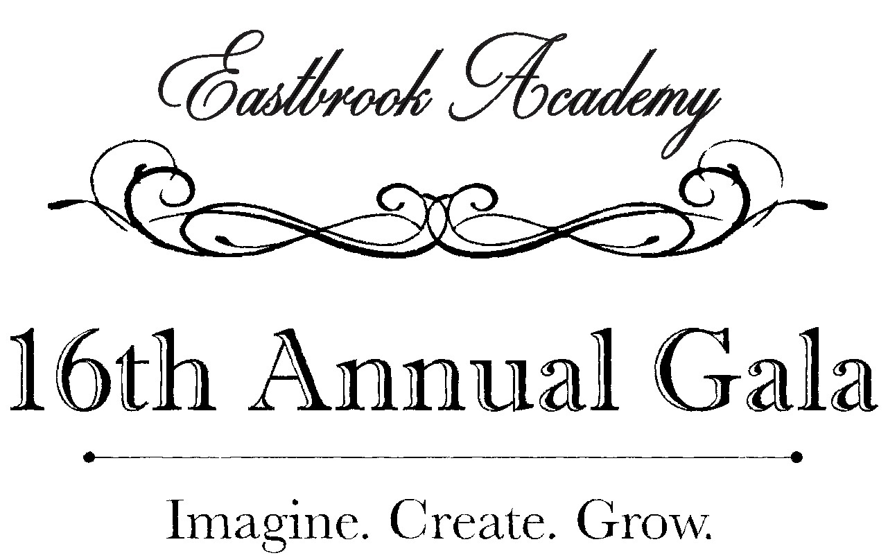

PRESENTING SPONSOR - $10,000 (One available)
- Exclusively named as lead event sponsor
- Company name and logo given Premium placement on auction bidding home and item page
- Company’s name and logo used in all event publicity
- Company logo and website link displayed on eastbrookacademy.org
- Premier signage and looping video recognition throughout event
- Recognition during Head of School’s address
- Company’s name and logo prominently featured on a table sign
- Two ten person tables in prime location at the event
- Valet parking

IMAGINE LEVEL SPONSOR - $5,000
- Company name and logo given Premium placement on auction bidding page
- Company’s name and logo used in all event publicity
- Company logo and website link displayed on eastbrookacademy.org
- Company name and logo featured on signage and looping video
- Recognition during Head of School’s address
- Company’s name and logo prominently featured on a table sign
- Ten person table at the event
- Valet parking

CREATE LEVEL SPONSOR - $2,500
- Company name and logo given Standard placement on auction bidding home and item page
- Company logo used in all event publicity
- Company logo displayed on eastbrookacademy.org
- Company logo featured on looping video
- Recognition during Head of School’s address
- Company name prominently featured on a table sign
- Ten person table at the event
- Valet parking

GROW LEVEL SPONSOR - $1,000
- Company name and logo given Standard placement on auction item page
- Company name used in all event publicity
- Company name displayed on eastbrookacademy.org
- Company name prominently featured on a table sign
- Ten person table at the event
- Valet parking

Company Name:

Contact Name:

Address:

City, State, Zip:

Telephone: E-mail:

YES! My company will support Eastbrook Academy with a sponsorship contribution of:

  - PRESENTING Level Sponsor - $10,000 Contribution
  - IMAGINE Level Sponsor - $5,000 Contribution
  - CREATE Level Sponsor - $2,500 Contribution
  - GROW Level Sponsor - $1,000 Contribution
___ Check enclosed ____ Will pay online
____Please keep my gift anonymous

Additionally, we will support Eastbrook Academy with an in-kind contribution of:

  - Silent Auction item: (sports tickets, memorabilia, restaurant gift cards, etc.)

  - Voice Auction item: (vacation homes, airfare, golf outing, etc.)

PLEASE RETURN THIS COMPLETED FORM WITH PAYMENT BY January 26, 2018 TO ENSURE YOUR COMPANY NAME WILL BE PRINTED ON THE INVITATION:

(A receipt for this tax-deductible donation will be sent to you.)
Eastbrook Academy
Kimberly Carrigan
414.228.7905 x 376
5375 North Green Bay Ave.
Milwaukee, WI 53209
kcarrigan@eastbrookacademy.org

