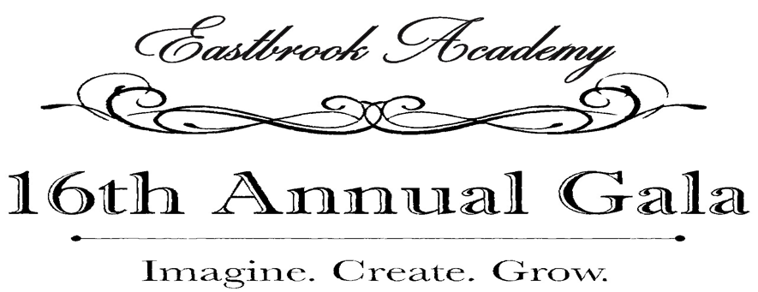

__________YES!
I would like to support Eastbrook Academy!
I would like to donate the following: (please copy this form as need)

_________________________________________________________________ $___________________________
Donation Description Retail Value

_____________________________________________________________________________________________
Your Name Title

_____________________________________________________________________________________________
Email Address

_________________________________________________________________ ____________________________
Company Name Phone

_____________________________________________________________________________________________
Company Address

_____________________________________________ _____________ ____________________________
City State Zip Code

_____ Please contact me to arrange a pick up time for this donation.

_____ I have enclosed the donation with this form.

Please return this form by mail to:

Kimberly Carrigan
Eastbrook Academy
5375 North Green Bay Avenue
Milwaukee, WI 53209

PLEASE RETAIN A COPY OF THIS FORM FOR YOUR RECORDS
Eastbrook Academy’s tax exempt number is EIN 39-1926815
THANK YOU FOR YOUR GENEROSITY!

